Supplementary Table 1. Summary of trail-level characteristics of included trails.
Items | Asia-Pacific | REFLECT | CheckMate-459 | KEYNOTE-240 | IMbrave 150 | SILIUS | HAIC-oxaliplatin | HAIC-oxaliplatin + Sorafenib
Region | International-collaborated | International-collaborated | International-collaborated | International-collaborated | International-collaborated | Japan | Mainland China | Mainland China
Inclusion period | 2005–2007 | 2013–2015 | 2016–2017 | 2016–2017 | 2018–2019 | 2010–2014 | 2012–2015 | 2016–2017
Phase | III | III | III | III | III | III | III | III
Sample size of experimental arm, n | 150 | 478 | 371 | 278 | 336 | 102 | 180 | 125
Control arm | Placebo | Sorafenib | Sorafenib | Placebo | Sorafenib | Sorafenib | Sorafenib | Sorafenib
Key eligibility criteria | Unresectable or metastatic HCC; No systemic therapy previously. | Unresectable or progressive HCC; No systemic therapy previously. | HCC that is not amenable to curative surgery or local treatment; No other agent targeting T-cell costimulation or checkpoint pathways therapies. | HCC that is not amenable to or refractory to locoregional therapy; Do not receive prior immunotherapy other than sorafenib. | HCC that is locally advanced metastatic or unresectable hepatocellular carcinoma (or both). | Patients with advanced HCC were not candidates for hepatectomy, local ablation therapy, or transarterial chemoembolization. | HCC at BCLC-C stage and refused to receive sorafenib. | HCC not suitable for curative surgery, or local ablation, and had portal vein invasion confirmed by 2 imaging techniques.
Experimental regimen | Molecular Targeted Agents: Sorafenib 400 mg bid or until disease progression or unaccseptable toxicity | Molecular Targeted Agents: Lenvatinib 12 mg/day (for bodyweight ≥60 kg) or 8 mg/day (for bodyweight <60 kg) in 28-day cycles | Anti-PD-1: Nivolumab 240 mg IV q2wks until disease progression or unacceptable toxicity occurred. | Anti-PD-1: Pembrolizumab 200 mg q3wks for up to 35 cycles until disease progression or unacceptable toxicity occurred. | Anti-PD-L1 + Bevacizumab: 1200 mg of atezolizumab plus 15 mg per kilogram of body weight of bevacizumab intravenously every 3 weeks. | Sorafenib + hepatic arterial infusion chemotherapy: Cisplatin 20 mg/m² per day on days 1 and 8, fluorouracil 330 mg/m² per day on days 1–5 and 8–12 and sorafenib 400 mg orally twice daily of every 28-day cycle, followed by 2 weeks off. | Hepatic arterial infusion: oxaliplatin 130 mg/m² for three hours followed by leucovorin 200 mg/m² for two hours on day 1 and Fluorouracil 400 mg/m² in bolus, and then 2400 mg/m² continuous infusion for 46 hours. | HAIC + Sorafenib: oxaliplatin 130 mg/m² for three hours followed by leucovorin 200 mg/m² for two hours on day 1 and Fluorouracil 400 mg/m² in bolus, and then 2400 mg/m² continuous infusion for 46 hours on days 1 and 2 via hepatic artery. Sorafenib 400 mg orally twice daily for 3-week cycle until disease progression or unacceptable toxicity occurred.
Abbreviations: HAIC, hepatic arterial infusion chemotherapy; NR, not reported; q2/3wks, every 2/3 weeks; PD-1, programmed death-1.

Supplementary Table 2. Summary of patient-level characteristics and clinical endpoints of included trails.
Items |  | Asia-Pacific | REFLECT | CheckMate-459 | KEYNOTE-240 | IMbrave 150 | SILIUS | HAIC-oxaliplatin | HAIC-oxaliplatin + Sorafenib
Sample size, n |  | 150 | 478 | 371 | 278 | 336 | 102 | 180 | 125
Control arm |  | Placebo | Sorafenib | Sorafenib | Placebo | Sorafenib | Sorafenib | Sorafenib | Sorafenib
Patient-level characteristics
 | Age, median (range), years | 51.0 (23.0–86.0) | 63.0 (20.0–88.0) | 63.9 (10.6) | 67.0 (18.0–91.0) | 64 (56.0–71.0) | 69.0 (62.0–75.0) | 51.0 (25.0–77.0) | 49.0 (41.0–55.0)
 | Sex, male, n (%) | 127 (84.7) | 405 (84.7) | 314 (84.6) | 226 (81.3) | 277 (82.4) | 89 (87.3) | 160 (88.9) | 111 (88.8)
 | PD-L1 expression#
 | < 1%, n (%) | NR | NR | 295 (79.5) | NR | 45 (36.0)§ | NR | NR | NR
 | ≥ 1%, n (%) | NR | NR | 71 (19.1) | NR | 79 (64.0)§ | NR | NR | NR
 | Macroscopic vascular invasion, n (%) | 54 (36.0) | 109 (22.8) | NR | 36 (12.9) | 129 (38.4) | 73 (71.6) | 98 (54.4) | 125 (100.0)
 | Extrahepatic spread, n (%) | 103 (68.7) | 291 (60.9) | NR | 195 (70.1) | 212 (63.1) | 26 (25.2) | 136 (58.6) | 38 (30.4)
 | Alpha-fetoprotein profiles* | 116 (77.3%) > ULN | 222 (46.4%) ≥ 200 ng/mL | NR | 129 (46.4%) ≥ 200 ng/mL | 126 (38.0%) ≥ 400 ug/mL | 49 (48.0%) ≥ 400 ug/mL | 93 (51.7%) ≥ 400 ug/mL | 76 (60.8%) > 1000 ng/mL
 | Hepatitis B, n (%) | 106 (70.7) | 251 (52.5) | NR | 72 (25.9) | 164 (48.8) | 26 (25.5) | 156 (86.7) | 100 (80.0)
 | Child-Pugh class B, n (%) | 4 (2.7) | 3 (1.0) | 0 (0.0) | 1 (0.4) | 0 (0.0) | 12 (12.0) | 61 (33.9) | 0 (0.0)
 | BCLC stage C, n (%) | 143 (95.3) | 374 (78.0) | NR | 222 (79.9) | 276 (82.1) | 70 (69.0) | 176 (97.8) | NR
 | Follow up interval, weeks | 6.0 | 8.0 | 4.0 | 6.0 | 6.0 | 4.0 | 6.0 | 6.0
Clinical endpoints
 | Median follow-up, months | NR | 27.7 | 22.8 | 13.8 | 8.9 | NR | 14.5 | NR
 | RECIST 1.1
 | ORR, n (%) | 5 (3.3) | 90 (18.8) | 57 (15.4) | 51 (18.3) | 89 (27.3) | NR | 53 (29.4) | 51 (40.8)
 | PR, n (%) | 0 (0.0) | 2 (0.4) | 14 (3.7) | 6 (2.2) | 18 (5.5) | NR | 0 (0.0) | 0 (0.0)
 | CR, n (%) | 5 (3.3) | 88 (18.4) | 43 (11.6) | 45 (16.2) | 71 (21.8) | NR | 53 (29.4) | 51 (40.8)
 | SD, n (%) | 81 (54.0) | 258 (54.0) | 69 (18.6) | 122 (43.9) | 151 (46.3) | NR | 89 (49.4) | 43 (34.4)
 | PD, n (%) | 46 (30.7) | 84 (17.6) | 245 (66.0) | 90 (32.4) | 64 (19.6) | NR | 38 (21.1) | 25 (20.0)
 | mRECIST
 | ORR, n (%) | NR | 194 (40.6) | NR | NR | 108 (33.2) | 37 (36.3) | 88 (48.9) | 68 (54.4)
 | CR, n (%) | NR | 10 (2.1) | NR | NR | 33 (10.2) | 8 (7.8) | 2 (1.1) | 10 (8.0)
 | PR, n (%) | NR | 184 (38.5) | NR | NR | 75 (23.1) | 29 (28.4) | 86 (47.8) | 58 (46.4)
 | SD, n (%) | NR | 159 (33.3) | NR | NR | 127 (39.1) | 29 (28.4) | 57 (31.7) | 27 (21.6)
 | PD, n (%) | NR | 79 (16.5) | NR | NR | 66 (20.3) | 16 (15.7) | 37 (20.6) | 24 (19.2)
 | OS
 | Median (months) | 6.5 | 13.6 | 16.4 (13.9–18.4) | 13.9 | Not reached | 11.8 | 14.5 | 13.4
 | 1-year rate (%) | 28.6 | 54.1 | 59.7 (54.4–64.6) | 54.7 | 67.2 (61.3–73.1) | 51.8 | 66.7 | 56.8
 | 6-month rate (%) | 53.3 | 80.7 | NR | 76.6 | 84.8 (80.9–88.7) | 70.4 | 95.4 | 82.4
 | PFS
 | Median (months) | 2.8 | 7.4 | 3.7 (3.1–3.9) | 3.0 | 6.8 (5.7–8.3) | 4.8 | 7.4 | 7.0
 | 1-year rate (%) | 5.6 | 31.5 | NR | 19.4 | 33.4 | 25.9 | 16.4 | 34.3
 | 6-month rate (%) | 21.1 | 56.9 | NR | 34.7 | 54.5 | 36.1 | 43.4 | 61.1
 | Any grade AEs, n (%) | 146 (98.0) | 447 (93.5) | 339 (92.4) | 269 (96.4) | 323 (98.2) | 88 (86.3) | 160 (88.9) | 118 (95.2)
 | Grade 3-5 AEs, n (%) | 71 (48.6) | 270 (57.4) | 81 (22.0) | 147 (54.6) | 201 (61.1) | 30 (34.1) | 15 (9.4) | 66 (53.2)
 | AEs led to discontinue, n (%) | 29 (19.5) | 42 (8.9) | 16 (4.0) | 48 (17.2) | 23 (7.1) | 26 (29.5) | 0 (0.0) | 32 (25.8)
 | AEs led to death, n (%) | 0 (0.0) | 0 (0.0) | 1 (0.3) | 7 (2.5) | 0 (0.0) | 0 (0.0) | 0 (0.0) | 2 (1.6)
Abbreviations: HAIC, hepatic arterial infusion chemotherapy; NR, not reported; BCLC, barcelona clinic liver cancer; ORR, objective response rate; PR, partical response; CR, complete response; SD, stable disease; PD, progressive disease; RECIST, Response Evaluation Criteria in Solid Tumors; mRECIST, modified Response Evaluation Criteria in Solid Tumors; OS, Overall survival; PFS, progression-free survival; PD-L1, programmed death-ligand 1; AEs, adverse events.
#Methods of PD-L1 expression evaluation, CheckMate-459 study: The PD-L1 expression was assessed baseline on an archived formalin-fixed, paraffin-embedded tumor sample with the use of a rabbit monoclonal anti-human PD-L1 antibody (clone 28-8) and an automated assay (PD-L1 IHC 28-8 pharmDx) developed by Dako North America (Carpinteria, CA, USA). PD-L1 positivity was defined as membranous staining on 1% or more of a modified proportion score or interface pattern.
*alpha-fetoprotein was demonstrated depending on the studies provided.
§Fresh tissue was not mandatory for this trial and, consequently, tissue was collected from 182 of 501 (36%) enrolled patients.

Supplementary Table 3. Incidence of major treatment-related adverse events for each regimen.
 | Asia-Pacific |  | REFLECT |  | CheckMate 459 |  | KEYNOTE-240 |  | IMbrave 150 |  | SILIUS |  | HAIC-oxaliplatin |  | HAIC-oxaliplatin + Sorafenib
Sample size, n | 149 |  | 476 |  | 371 |  | 279 |  | 336 |  | 88 |  | 180 |  | 124
 | 1–5 Grade (%) | 3–5 Grade (%) | 1–5 Grade (%) | 3–5 Grade (%) | 1–5 Grade (%) | 3–5 Grade (%) | 1–5 Grade (%) | 3–5 Grade (%) | 1–5 Grade (%) | 3–5 Grade (%) | 1–5 Grade (%) | 3–5 Grade (%) | 1–5 Grade (%) | 3–5 Grade (%) | 1–5 Grade (%) | 3–5 Grade (%)
Fatigue | 20.1 | 3.4 | 30.0 | 4.0 | 27.8 | 0.3 | 18.6 | 2.5 | 20.4 | 2.4 | 24.0 | 10.0 | 69.0 | 0.0 | 76.6 | 6.5
Weight loss | NR | NR | 31.0 | 8.0 | NR | NR | 1.1 | 0.4 | 11.2 | 0.0 | 39.8 | 0.0 | 28.0 | 0.0 | 35.5 | 0.8
Alopecia | 24.8 | 0.0 | 3.0 | 0.0 | 1.6 | 0.0 | NR | NR | 1.2 | 0.0 | 9.0 | 0.0 | NR | NR | 79.8 | 0.0
Hand-foot skin reaction | 45.0 | 10.7 | 27.0 | 3.0 | NR | NR | 2.9 | 2.2 | NR | NR | 42.0 | 9.0 | NR | NR | 41.1 | 10.5
Hypothyroidism | NR | NR | 16.0 | 0.0 | 7.6 | 0.0 | 5.0 | 0.4 | NR | NR | NR | NR | NR | NR | NR | NR
Pruritus | NR | NR | NR | NR | 22.4 | 1.0 | 18.3 | 0.4 | 19.5 | 0.0 | NR | NR | NR | NR | NR | NR
Rash or desquamation | 20.1 | 0.7 | 9.7 | 0.0 | 19.4 | 0.5 | 11.5 | 0.7 | 12.5 | 0.0 | NR | NR | NR | NR | 12.1 | 0.0
ALT increase | NR | NR | NR | NR | 13.9 | 0.0 | 17.6 | 6.1 | 14.0 | 3.6 | 60.2 | 14.8 | 30.0 | 0.0 | 69.4 | 11.3
AST increase | NR | NR | 13.7 | 5.0 | 22.1 | 0.0 | 22.6 | 13.3 | 19.5 | 7.0 | 68.2 | 29.5 | 62.2 | 5.0 | 80.7 | 29.0
TBIL increase | NR | NR | 15.0 | 7.0 | 10.9 | 0.3 | 18.6 | 7.5 | 13.1 | 2.4 | 57.0 | 8.0 | 11.0 | 0.0 | 73.4 | 4.8
Lipase | NR | NR | NR | NR | 9.8 | 0.0 | NR | NR | NR | NR | 33.0 | 30.0 | NR | NR | NR | NR
Serum amylase | NR | NR | NR | NR | 6.5 | 0.0 | NR | NR | 1.2 | 0.3 | 40.0 | 11.0 | NR | NR | NR | NR
Anemia | NR | NR | NR | NR | NR | NR | 9.7 | 3.9 | 9.1 | 2.7 | 71.6 | 17.0 | 7.8 | 2.2 | 68.6 | 4.8
Diarrhea | 25.5 | 6.0 | 38.7 | 4.2 | 26.7 | 1.1 | 17.2 | 1.4 | 18.8 | 1.8 | 29.5 | 4.5 | 13.3 | 0.0 | 29.0 | 8.9
Constipation | NR | NR | 16.0 | 1.0 | 13.4 | 0.0 | 9.3 | 0.4 | 13.4 | 0.0 | NR | NR | 21.7 | 0.0 | NR | NR
Neutropenia | NR | NR | NR | NR | NR | NR | NR | NR | 3.6 | 1.5 | 52.3 | 17.0 | 17.8 | 5.6 | 44.4 | 9.7
Nausea | 11.4 | 0.7 | 20.0 | 1.0 | 16.4 | 0.0 | 11.5 | 0.7 | 12.2 | 0.3 | 33.0 | 6.0 | 15.0 | 0.0 | 79.8 | 7.3
Vomiting | NR | NR | 16.2 | 1.3 | 9.5 | 0.0 | NR | NR | 10.0 | 0.6 | 17.0 | 3.4 | 14.4 | 6.7 | 59.7 | 6.5
Hoarseness | NR | NR | 24.0 | 0.2 | NR | NR | NR | NR | NR | NR | 16.0 | 0.0 | NR | NR | NR | NR
Thrombocytopenia | NR | NR | 18.3 | 5.5 | NR | NR | NR | NR | 8.2 | 1.8 | 58.0 | 34.1 | 18.3 | 3.3 | 55.6 | 12.9
Hypertension | 18.8 | 2.0 | 42.2 | 23.3 | 8.7 | 0.0 | NR | NR | 29.8 | 15.2 | 52.3 | 25.0 | 1.1 | 0.0 | 27.4 | 2.4
Abdominal pain | NR | NR | 17.0 | 2.0 | 18.3 | 1.9 | 14.3 | 1.4 | 12.2 | 1.2 | NR | NR | 43.8 | 0.0 | 35.5 | 6.5
Decreased appetite | 12.8 | 0.0 | 34.0 | 4.6 | 20.7 | 0.0 | 17.2 | 1.1 | NR | NR | NR | NR | NR | NR | NR | NR
Peripheral edema | NR | NR | NR | NR | 11.2 | 0.3 | 11.5 | 0.0 | NR | NR | NR | NR | NR | NR | 16.9 | 4.0
Back pain | NR | NR | NR | NR | 10.1 | 0.5 | 9.7 | 1.4 | NR | NR | NR | NR | 13.0 | 0.0 | NR | NR
Pyrexia | NR | NR | NR | NR | 19.4 | 1.9 | 9.3 | 0.7 | 17.9 | 1.2 | 24.0 | 0.0 | 7.0 | 0.0 | 12.9 | 1.6
Arthralgia | NR | NR | NR | NR | 11.2 | 0.0 | 7.2 | 0.4 | NR | NR | NR | NR | NR | NR | NR | NR
Elevated INR | NR | NR | NR | NR | NR | NR | NR | NR | NR | NR | 47.0 | 0.0 | 12.0 | 0.0 | NR | NR
Hypoalbuminemia | NR | NR | NR | NR | 5.2 | 0.0 | NR | NR | NR | NR | NR | NR | 35.0 | 3.0 | 81.5 | 4.8
Sensory neuropathy | NR | NR | NR | NR | NR | NR | NR | NR | NR | NR | NR | NR | 7.0 | 0.0 | 32.3 | 0.0
Elevated creatinine | NR | NR | NR | NR | 0.3 | 0.3 | NR | NR | NR | NR | NR | NR | 3.0 | 0.0 | NR | NR
Data presented as percentage, if not specified.
Abbreviations: HAIC, hepatic arterial infusion chemotherapy; NR, not reported; ALT, alanine aminotransferase; AST, aspartate aminotransferase; INR, international normalized ratio; TBIL, total bilirubin.

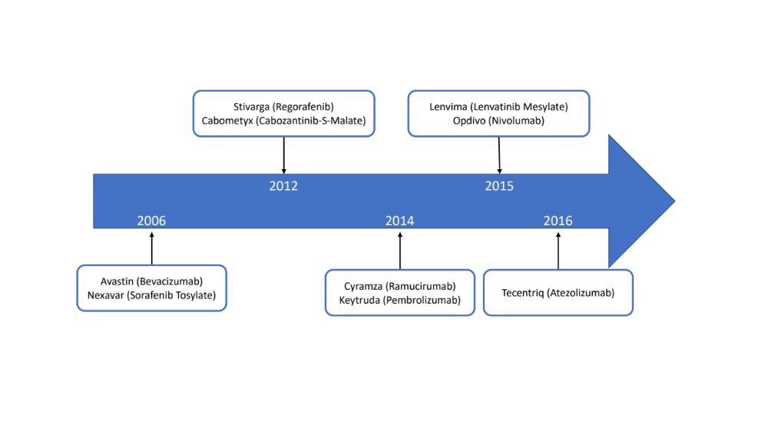
Supplementary Fig. 1. Timeline of the drugs development for advanced hepatocellular carcinoma.

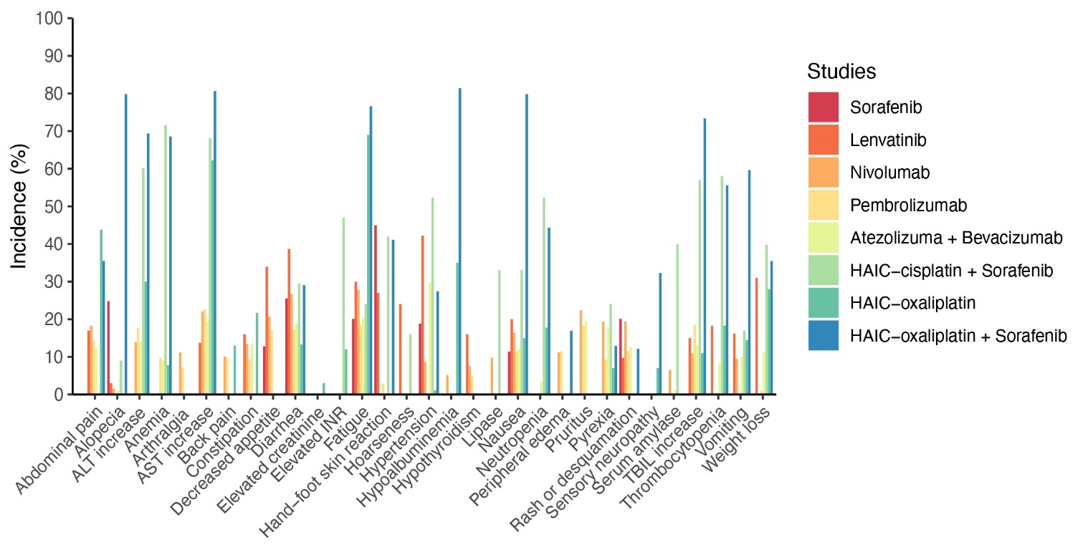
Supplementary Fig. 2. Safety profiles of molecularly targeted drugs, immune checkpoint inhibitors, hepatic arterial infusion chemotherapy alone, or their combination in advanced hepatocellular carcinoma. Bar plot depicts the 1–5 grade toxicity spectra based on each of the specific adverse event. AE, adverse event; HAIC, hepatic arterial infusion chemotherapy; ALT, alanine aminotransferase; AST, aspartate aminotransferase; INR, international normalized ratio; TBIL, total bilirubin.

